Board Member: Application Form

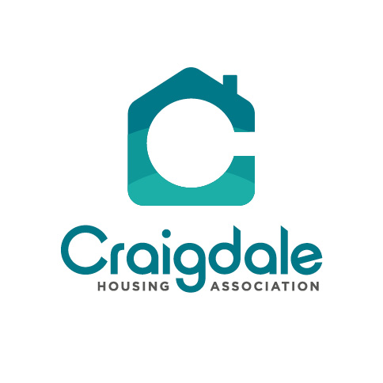

- Personal Details

Name:
Address:
Telephone | H:
 | M:
Email:

- Reference Details (Please include the names of two people who would be happy to recommend you to the position of Board Member)

Name:
Address:
Postcode:
Contact number (s):
Relationship to you:
Name:
Address:
Postcode:
Contact number (s):
Relationship to you:

- Why do you wish to join the Board? Please tell us why you want to join the Board, what you can offer and why you would make a good Board Member. Please continue on a separate sheet if necessary.

- Relevant Skills and Knowledge (Please give details below)

- Employment (Please provide brief details below and continue on a separate sheet if necessary).
Current Employment:
Address:
Your Position or Role:
Brief description of your responsibilities:

- Voluntary Role (Please provide brief details below and continue on a separate sheet if necessary).
Name of Business:
Your Position or Role:
Brief description of your responsibilities:

- Public Position Held:

- Qualifications  (professional,  academic, other) | (1)
- Qualifications  (professional,  academic, other) | (2)
- Qualifications  (professional,  academic, other) | (3)
- Qualifications  (professional,  academic, other) | (4)
- Qualifications  (professional,  academic, other) | (5)
- Qualifications  (professional,  academic, other) | (6)

- Personal and Business Relationships: Please tell us if you have any relationships (such as family or personal relationships or business dealings) with any Board Member or employee of Craigdale Housing Association.

- Eligibility to act as Board Member. You must tell us if any of the following apply to you:

- Have you ever been the director of a company that has gone into insolvent liquidation? | YES / NO
- Have you ever been convicted of a serious criminal offence (in particular involving dishonesty, any offence relating to a company)? | YES / NO
- Have you been declared bankrupt or are facing bankruptcy proceedings? | YES / NO

If you have answered yes to any of the above questions, please give details below.

- Signature

Signed:
Print Name:
Date:

If selected for interview, do you require any assistance to attend and participate in the interview? No. If ‘yes’ please provide details.

Please send this completed application form to:

Frances Cunningham, Corporate Manager
Craigdale Housing Association Ltd
83-85 Dougrie Road
Castlemilk
Glasgow, G45 9NS

Or email to: frances@craigdaleha.co.uk

Please note that we will acknowledge receipt of all applications. If you do not receive an acknowledgement, then this may indicate that the application has not been received through our email system. Should this take place you must contact us no later than 19th June 2024.

- Equality and Diversity Monitoring

Craigdale is committed to having a diverse workforce. We welcome applications from men and women irrespective of their ethnic or national origin, disability, age, marital status, sexual orientation, race, colour, nationality, or religion.

In order to assist us to monitor the success of our diversity policy, please complete this section. This information will only be used for monitoring purposes and will be processed separately from your application for employment – it will not be used as part of the selection process. Providing this information is voluntary. If you do not want to provide it, leave this section blank.

Gender: | Male |  | Female

Age (tick the appropriate box)

16-24 |  | 55-59
25-34 |  | 60-64
35-44 |  | 65-74
45-54 |  | 75+

Relationship Status (tick the appropriate box)

Single |  | Divorced
Married |  | Formerly in a same sex civil Partnership which is now legally dissolved
In a same sex civil partnership |  | Widowed
Separated |  | I prefer not to say
Living with partner

Religious Denomination (tick the appropriate box)

None |  | Muslim
Church of Scotland |  | Buddhist
Roman Catholic |  | Jewish
Sikh |  | I prefer not to say
Pagan

Sexual Orientation (tick the appropriate box)

Bisexual |  | Other
Gay, Lesbian or Homosexual |  | I prefer not to say
Heterosexual

Ethnic Group (tick the appropriate box)

White: Scottish |  | Asian, Asian Scottish or Asian British
White: English |  | Pakistani, Pakistani Scottish or Pakistani British
White: British |  | Indian, Indian Scottish or Indian British
White: Polish |  | African, Caribbean or Black African, African Scottish or African British
White: Irish |  | African, Caribbean or Black, Black Scottish or Black British
White: Northern Irish |  | Other ethnic group
White: Gypsy - Traveller |  | I prefer not to say

Do you have any of the following conditions, which have lasted or are expected to last, at least 12 months? (TICK ALL THAT APPLY)
Deafness or severe hearing impairment |  | A mental health condition (such as depression or schizophrenia)
Blindness or severe vision impairment

A physical disability (a condition that substantially limits one or more basic physical activities such as walking, climbing stairs, lifting or carrying) |  | A chronic illness (such as cancer, Human immunodeficiency virus (HIV), diabetes, heart disease or epilepsy
A learning disability (such as Down’s Syndrome) |  | Other condition
A learning difficulty (such as dyslexia or dyspraxia) |  | I have no condition(s)

