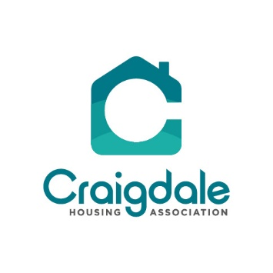

You will be aware that the latest variant of Covid 19, Omicron, is having a major impact on services all around the Country. As a community-based organisation Craigdale have endeavoured to deliver normal services throughout the pandemic, however due to the amount of people either with the virus or having to isolate our small staff team are unable to maintain this at the moment.

Therefore, unfortunately due to this latest variant we are changing the way services are delivered to you. From Monday 10th January 2022 the office will be closed to people just dropping in. However, if you really need to see a member of staff you will be able to make an appointment to come to the office.

We would ask though that if your query can be dealt with by phone, email, or video call that this is the method of communication used. We will be monitoring this situation very closely and will only leave these changes in place for as long as we have to. We will put any updates on the website and the Facebook page so please check regularly.

If you are making an appointment you will need to follow these guidelines:

- If you are able take a lateral flow test before attending if this is positive let us know immediately. The staff will be testing on a daily basis.

- If you have any covid symptoms such as a persistent cough or high temperature, please contact us to rearrange the appointment.

- Please bring a pen with you.

- Wear a facemask at all times within the building.

- Do not arrive early for the appointment ensure you arrive on time; this limits too many people being in the reception area at one time.

- Ensure that you maintain a two-meter distance to staff during the appointment.

These guidelines are to protect both yourself and the staff members.

The Welfare Rights service will continue but this may be cancelled at any time as there is only one member of staff qualified to undertake this service and it will be by appointment only.

P.T.O….

