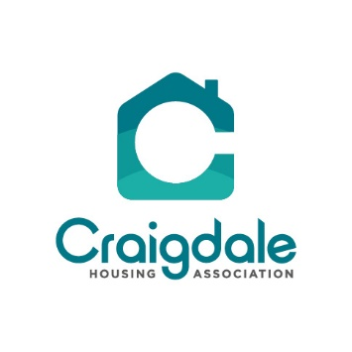

The repair service will continue as normal but if you have a contractor visiting, we ask you to follow the following guidelines:

- Take a lateral flow test, if possible, before the contractor appointment if this is positive let us know immediately and the repair will either be rearranged or if it is an emergency, we will give you further instructions of how the repair will proceed. All contractors are testing on a daily basis.

- Open windows, we realise that it isn’t the best time of year for open windows, but it will protect you and the contractor if the area is well ventilated.

- If you have any covid symptoms such as persistent cough, high temperature or change of taste and/or smell contact us immediately for further instructions.

- Ensure that you maintain a safe distance from the contractor at all times.

The decision to alter services hasn’t been taken lightly but rest assured that the changes will only be in place for as short a period as necessary and as soon as we are able, we will be taking away restrictions and reopening as normal.

Thank you for your continued support during these times, if you are struggling with any aspect of the changes or wish to discuss anything regarding them then please don’t hesitate to contact me.

Yours sincerely

Linda Chelton
Linda Chelton – Chief Executive Officer

